USDA Foreign Agricultural Service
GAIN Report

Global Agriculture Information Network
Template Version 2.08

Required Report - public distribution
Date: 12/4/2003
GAIN Report Number: SF3041
SF3041
South Africa, Republic of
Avocado
Annual
2003

Approved by:
Scott Reynolds
U.S. Embassy, South Africa
Prepared by:
Patricia Mabiletsa

Report Highlights:
South Africa's FAS 2002, (MY 2003) avocado production, at 84,000 tons, is estimated to have decreased by 23% compared to the previous season, mainly due to the alternate bearing nature of the avocado. The fruit size was also smaller due to high temperatures and insufficient moisture. Post estimates that the smaller crop led to a 20% decrease in exports. The 2003 (MY 2004) crop is expected to bounce back to about 100,000 tons. Most exports are destined for Europe, where awareness is well established, but the industry is considering expanding exports to Japan and the US.

Includes PSD Changes: Yes
Includes Trade Matrix: Yes
Annual Report
Pretoria [SF1]
[SF]

Executive Summary

South Africa’s FAS 2002, MY 2003, avocado production is estimated to have declined about 23% from the previous season because of the alternating bearing nature of the avocado plants. The fruit size was also small, as a result of high temperatures and insufficient moisture. Further problems encountered included sunburn injury, especially for Hass varieties.

The trade estimate for MY 2003 is that 38,000 Mt. was exported, 35,000 MT of which was destined for Europe. The industry projects an increase in annual exports of roughly 12,000 Mt. by 2012. More Hass than Green skins are exported to Europe. The industry expects to continue with generic promotion in Europe. Locally, fresh produce markets remain major channels for avocados.

Major challenges for the avocado industry are to expand the processing industry, to continue with generic promotions both in South Africa and Europe, to continue to communicate with competitor countries to prevent unnecessary supply peaks in Europe, and to overcome phytosanitary barriers that will allow access to new markets. The industry plans to target the United States as a new market.

The Avocado Growers Association (SAAGA) was formed in the late 1960’s to promote the interests of avocado farmers in South Africa. SAAGA collects, collates, and disseminate information for members; encourages coordination of export and local marketing; facilitates research; and promotes avocado consumption both locally and abroad. SAAGA is the largest organization in the subtropical fruit sector and consists of voluntary membership of about 450 growers, cooperators, and exporters. The Association produces about 90% of the total crop, and serves production areas from Louis Trichardt in the Limpopo Province, Tzaneen, Burgershall White River and Nelspruit, Kwazulu Natal, and a small area of the Western Cape.

The avocado production extends to an area of about 12,000 Ha, with an annual production capacity of between 85,000 – 110,000 MT. Future production is forecast at an annual increase of about 2%. The production season for South African avocados is between March and October. During this period, South Africa’s major competitors within the European markets are Spain, Peru, Kenya, and Israel.

South Africa’s producers of sub-tropical fruits are not the largest suppliers of export fruit in the world, although they dominate certain markets at given times of the year.

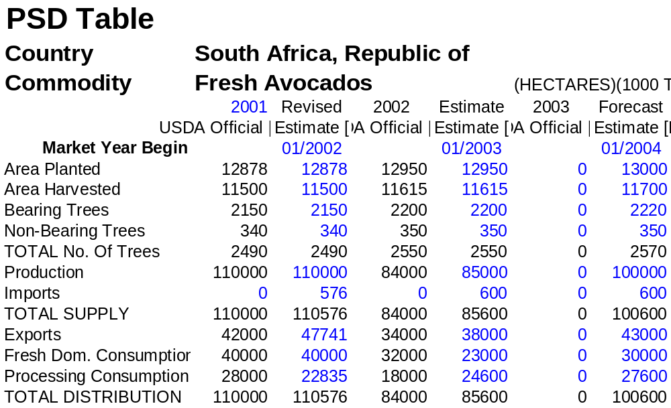
Production

South Africa’s MY 2003 avocado production decreased about 23% from the previous season because of alternating bearing nature of the avocado trees. The fruit size has been small, because of high temperatures and insufficient soil moisture contents. Sunburn injury was widespread this season, especially on the Hass variety. South Africa’s new Hass plantings totaled 100,000 trees in 2003.

Consumption

Annually, about 50% of the total subtropical fruits are sold in the local markets. In MY 2003, the fresh produce markets, which are major channels for supply of local avocados, remained firm and paid reasonable returns. As a result of the smaller crop the local market was undersupplied. The increase in processing consumption shown is the result of a rise in demand for fresh avocados for processing of oil and guacamole.

MY 2003 avocado prices in local markets were about R1,700/Mt. The table below indicates annual average prices for period 1992-2001.

AVOCADO PRICES IN LOCAL FRESH PRODUCE MARKETS ( 1992-2001)

YEAR | 1992 | 1993 | 1994 | 1995 | 1996 | 1997 | 1998 | 1999 | 2000 | 2001
PRICES  R/TON | 1,800 | 2,200 | 1,900 | 2,600 | 2,100 | 2,400 | 1,900 | 2,800 | 2,100 | 3,100

Trade

Exports

South Africa’s peak exports period starts in July and end in August. The main destination for exports is the EU. Japan and the United States are the markets the industry is targeting.
South Africa’s avocados have acquired a reputation for good quality, especially when compared with later fruits from main competitor countries (Israel, Kenya, Spain, and Peru).
Increased demand for the South African avocados in Europe also reduces storage costs.

Major challenges for the avocado industry include expanding the processing industry, to continue with generic promotions both in South Africa and Europe, to continue to communicate with competitor countries to prevent unnecessary supply peaks in Europe, and to overcome phytosanitary barriers that will allow access to new markets.

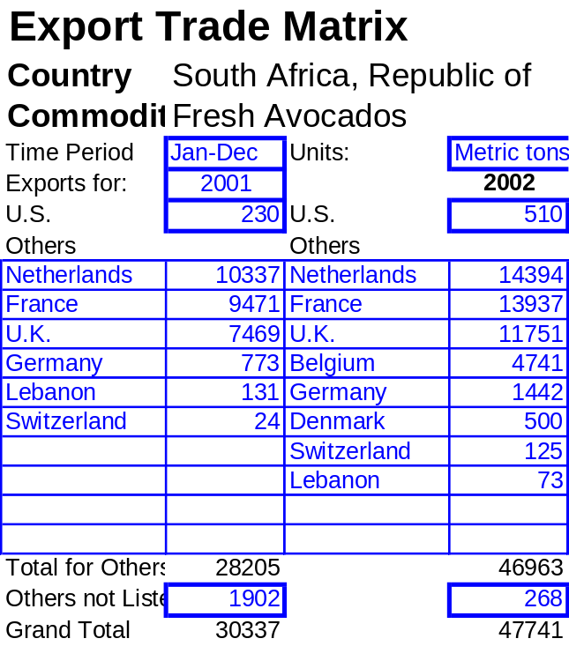
South African MY 2003 avocado exports probably totaled about 38,000 Mt. of which Europe received the largest share; about 36,000 Mt. South Africa already exported about 20,000 MT of Green skins and about 14,000 MT of Hass up to the end of August. Usually, more Hass than Green skins are exported to Europe because of consumer preferences. A larger export volume by air is predicted for the coming season.

The table below indicates the quantity of South African avocados exported from January to August 2003:

COUNTRIES | 2003 | METRIC
France | 11,227 | TONS
Netherlands | 10,641 | TONS
U.K. | 8,944 | TONS
Germany | 2,094 | TONS
Belgium | 670 | TONS
Denmark | 369 | TONS
Switzerland | 259 | TONS
Spain | 209 | TONS
United Arab Emirates | 128 | TONS
TOTAL | 34,541 | TONS

The start of this year’s export season was delayed because of inadequate ripeness of fruit. It also appears that a fair percentage of fruit was small in size and not readily acceptable in overseas markets. For MY 2004, rough projections for exports are about 23,200 MT for green skins, and an increase to about 19,600 MT for Hass.

Imports

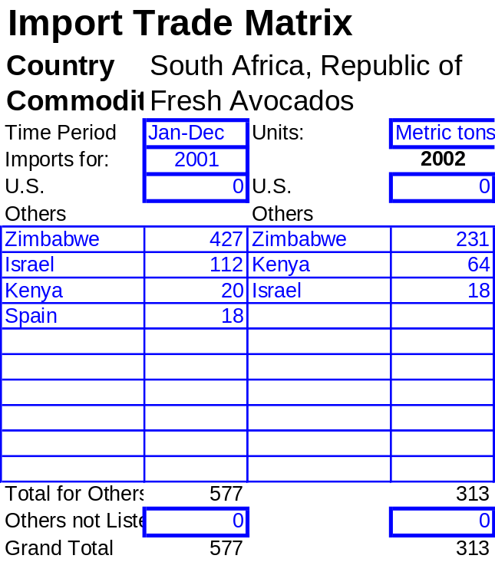The table below shows the quantity of South African avocado imports from Jan-August 2003.

COUNTRIES | 2003 | METRIC
Zimbabwe | 314 | TONS
Israel | 37 | TONS
Kenya | 18 | TONS
TOTAL | 369 | TONS

Policy

The South African National Accreditation System (SANAS) accredited the Perishable Product Export Control Board (PPECB) with the ISO 62 and ISO 65 status in 2002. The status enables PPECB to accredit local firms’ certificates for Hazard Analysis Critical Point (HACCP), Good Manufacturing Practices (GMP), Good Hygiene Practices (GHP), and Good Agricultural Practices (GAP), specifically EURO GAP. This follows the 2001’s ISO 9001 status and a certificate Agency approval for EURO GAP. The above follows a growing concern for food handling and consumption safety by both importing and exporting countries. Certificates serve as written guarantee to importers, wholesalers and retailers of safe handling, throughout the production, processing, and distribution chain.

South African food exporters are expected to comply with the new minimum European Union export standards for food safety and hygiene as also applied on EU-produced foodstuffs from January 2004. Affected are producers for all fresh fruit and vegetables, all canned fruit and vegetables, all frozen fruit and vegetables, dried fruit, groundnuts and grain, and rooibos and honeybush tea. For more information, visit the South Africa Department of Agriculture’s
Web site at www.nda.agric.za/docs/plantquality/default.htm

Marketing

SAAGA’s market promotion in the U.K. is well established under the slogan “Summer Avocados-Fresh from the South African Sun”. According to SAAGA, there is a strong linkage for increased European demand for avocado during South Africa’s peak exporting period. Export earnings from Europe, mainly the UK, increased in 2002 to reach an amount of R200 million because of the well-managed supply to avoid gluts. For more information, visit SAAGA’s website at www.avocado.co.za.

Growers, pack houses and exporters coordinate and manage weekly exports at regional levels by meeting regularly to study the European market trends. The Avocado industry and stakeholders established a Marketing and Promotion Working Group (AMAPWG) to share information on projected production and weekly shipments to Europe.

European consumers, more so than South Africans, prefer Hass to other varieties.

